**PORTFOLIO PROJECT**

Submitted by

## SANJAY KUMAR M

**Reg. No: 1P23MC048**

In partial fulfilment of the requirement for the award of the Degree of

## Master of Computer Applications Bharathiar University Coimbatore.

Under the Internal Supervision of

## Mrs. K. Swathy

**Faculty**

**School of Computer Studies-MCA**

## Master of Computer Applications,

**Rathnavel Subramaniam College of Arts and Science (Autonomous),**

## Sulur, Coimbatore – 641 402.

**Nov 2023**

## RATHNAVEL SUBRAMANIAM COLLEGE OF ARTS AND SCIENCE (AUTONOMOUS)

**AFFLIATED TO BHARATHIAR UNIVERSITY**

**NAAC Re-accredited & ISO 9000:2008 Certified SULUR, COIMBATORE-641402.**



**Nov 2023**

**Register Number – 1P23MC048**

Certified bona fide original record of work done by **SANJAY KUMAR M**

## Internal Supervisor Director

Submitted for the project Evaluation and Viva voce held on**………………….**

## Internal Examiner External Examiner

PORTFOLIO PROJECT

**Chapter-1:** 1

Video Introduction

1.1 YouTube video

**Chapter-2:** 2

Website Bio Score

* 1. About me
  2. Contact Information

**Chapter-3:** 8

Pages & Navigations

* 1. Landing Page
  2. Project Page
  3. Navigation Bar
  4. Skill Page

**Chapter-4:** 31

Style Score

* 1. Styles
  2. Style links

**Chapter-5:** 33

Website include the following Information

* 1. Project link to the Github
  2. Project Description

**Chapter-6:** 37

Bootstrap

6.1 Uses of Bootstrap

**Chapter-7:**  38

Project README

* 1. Title description
  2. How to run the project
  3. Future improvement in the project

**Chapter-8:** 43

File structure

8.1 Github file structure

PORTFOLIO PROJECT

## Chapter-1: Video introduction

**1.1** **YouTube video introduction**

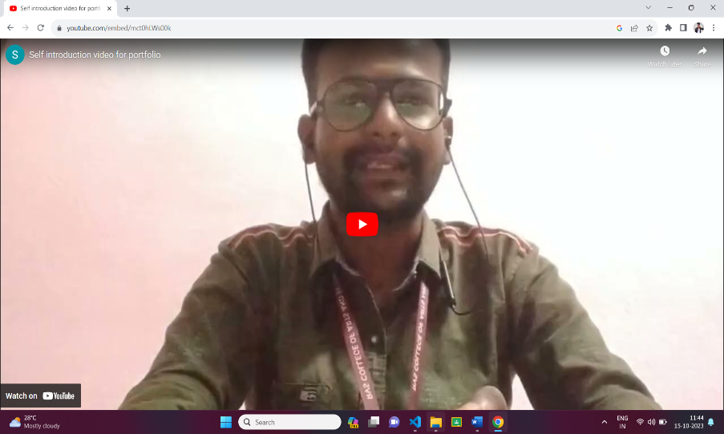

**Description:**

In this page, there is an Introduction video about me and my acadamic details for verification via Youtube. So, that if any user want to see the my all details, they can view here.

**Source code:**

<button type="button" class="btn-play" data-toggle="modal" data-target="#videoModal"

        data-src="https://www.youtube.com/embed/mct0hLWs00k">

        <span></span>

</button>

<h5 class="font-weight-normal text-white m-0 ml-4 d-none d-sm-block">Intro Video</h5>

# **About me**

## Chapter-2: Website Bio Score

**Description:**

In this page, there is an Image of mine, paragraph about me and also added my personal details for verification. So, that if any user want to see the my all details, they can view here.

**Source Code:**

# HTML:

<!-- About Start -->

    <div class="container-fluid py-5" id="about">

        <div class="container">

            <div class="position-relative d-flex align-items-center justify-content-center">

                <h1 class="display-1 text-uppercase text-white" style="-webkit-text-stroke: 1px #dee2e6;">About</h1>

                <h1 class="position-absolute text-uppercase text-primary">About Me</h1>

            </div>

            <div class="row align-items-center">

                <div class="col-lg-5 pb-4 pb-lg-0">

<img class="img-fluid rounded w-100" src="./resume/IMG202302130709581.jpg" alt="">

                </div>

                <div class="col-lg-7">

                    <h3 class="mb-4">Web Developer</h3>

                    <p>Hi there! I'm Sanjay Kumar M, a passionate Full-Stack developer with a keen eye for creating engaging and user-friendly web experiences. With a strong foundation in HTML, CSS, and JavaScript, I love translating design concepts into responsive, interactive websites that captivate users.</p>

                    <div class="row mb-3">

                        <div class="col-sm-6 py-2"><h6>Name: <span class="text-secondary">Sanjay Kumar M</span></h6></div>

                        <div class="col-sm-6 py-2"><h6>Birthday: <span class="text-secondary">13 February 2003</span></h6></div>

                        <div class="col-sm-6 py-2"><h6>Degree: <span class="text-secondary">Master of Computer Applications</span></h6></div>

                        <div class="col-sm-6 py-2"><h6>Phone: <span class="text-secondary">+91 7448433896</span></h6></div>

                        <div class="col-sm-6 py-2"><h6>Email: <span class="text-secondary">sandysanjay@gmail.com</span></h6></div>

                        <div class="col-sm-6 py-2"><h6>Address: <span class="text-secondary">Veerapandi, Tiruppur, TamilNadu.</span></h6></div>

                    </div>

                </div>

            </div><br>

            <a href="#" class="btn btn-outline-primary mr-4">Prev</a>

            <a href="#qualification" class="btn btn-outline-primary">Next</a>

        </div>

    </div>

    <!-- About End -->

CSS:

#about .container,#about .container-fluid {

    width: 100%;

    padding-right: 15px;

    padding-left: 15px;

    margin-right: auto;

    margin-left: auto;

  }

  #about .py-5 {

    padding-top: 3rem !important;

  }

.row {

  display: flex;

  flex-wrap: wrap;

  margin-right: -15px;

  margin-left: -15px;

}

  #about .row-cols-sm-6 > * {

      flex: 0 0 16.66667%;

      max-width: 16.66667%;

    }

  #about .col-lg-5 {

    flex: 0 0 41.66667%;

    max-width: 41.66667%;

  }

  #about .col-lg-7 {

    flex: 0 0 58.33333%;

    max-width: 58.33333%;

  }

  #about .mb-3 {

    margin-bottom: 1rem !important;

  }

  #about .mb-4 {

    margin-bottom: 1.5rem !important;

  }

@media (min-width: 576px) {

  .container, .container-sm {

    max-width: 540px;

  }

}

@media (min-width: 768px) {

  .container, .container-sm, .container-md {

    max-width: 720px;

  }

}

@media (min-width: 992px) {

  .container, .container-sm, .container-md, .container-lg {

    max-width: 960px;

  }

}

@media (min-width: 1200px) {

  .container, .container-sm, .container-md, .container-lg, .container-xl {

    max-width: 1140px;

  }

}

* 1. **Contact page**

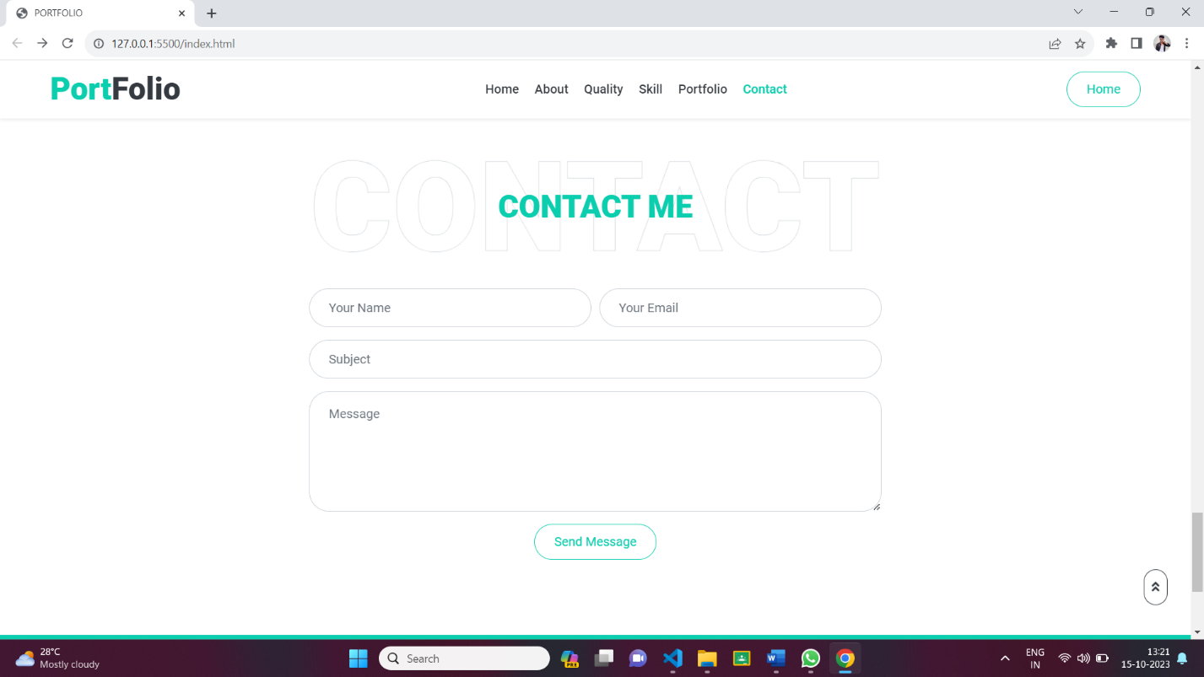

**Description:**

The above displayed figure is a contact page in the website. If the user wants to contact me, they can fill the formwith their valid details.

**Source Code:**

HTML:

 <!-- Contact Start -->

<div class="container-fluid py-5" id="contact">

    <div class="container">

        <div class="position-relative d-flex align-items-center justify-content-center">

            <h1 class="display-1 text-uppercase text-white" style="-webkit-text-stroke: 1px #dee2e6;">Contact</h1>

            <h1 class="position-absolute text-uppercase text-primary">Contact Me</h1>

        </div>

        <div class="row justify-content-center">

            <div class="col-lg-8">

                <div class="contact-form text-center">

                    <div id="success"></div>

                    <form name="sentMessage" action="https://formsubmit.co/sandysanjay1302@gmail.com" method="POST" id="contactForm" novalidate="novalidate">

                        <div class="form-row">

                            <div class="control-group col-sm-6">

                                <input type="text" class="form-control p-4" id="name" placeholder="Your Name"

                                    required="required" data-validation-required-message="Please enter your name" />

                                <p class="help-block text-danger"></p>

                            </div>

                            <div class="control-group col-sm-6">

                                <input type="email" class="form-control p-4" id="email" placeholder="Your Email"

                                    required="required" data-validation-required-message="Please enter your email" />

                                <p class="help-block text-danger"></p>

                            </div>

                        </div>

                        <div class="control-group">

                            <input type="text" class="form-control p-4" id="subject" placeholder="Subject"

                                required="required" data-validation-required-message="Please enter a subject" />

                            <p class="help-block text-danger"></p>

                        </div>

                        <div class="control-group">

                            <textarea class="form-control py-3 px-4" rows="5" id="message" placeholder="Message"

                                required="required"

                                data-validation-required-message="Please enter your message"></textarea>

                            <p class="help-block text-danger"></p>

                        </div>

                        <div>

                            <button class="btn btn-outline-primary" type="submit" id="sendMessageButton">Send

                                Message</button>

                        </div>

                    </form>

                </div>

            </div>

        </div>

    </div>

</div>

<!-- Contact End -->

CSS:

#contact .container,#contact .container-fluid {

  width: 100%;

  padding-right: 15px;

  padding-left: 15px;

  margin-right: auto;

  margin-left: auto;

}

#contact .py-5 {

  padding-top: 3rem !important;

}

.row {

  display: flex;

  flex-wrap: wrap;

  margin-right: -15px;

  margin-left: -15px;

}

#contact .col-lg-8,#contact col-sm-6 {

  position: relative;

  width: 100%;

  padding-right: 15px;

  padding-left: 15px;

}

#contact .contact-form,#contact .help-block ul {

  margin: 0;

  padding: 0;

  list-style-type: none;

}

@media (min-width: 576px) {

  .container, .container-sm {

    max-width: 540px;

  }

}

@media (min-width: 768px) {

  .container, .container-sm, .container-md {

    max-width: 720px;

  }

}

@media (min-width: 992px) {

  .container, .container-sm, .container-md, .container-lg {

    max-width: 960px;

  }

}

@media (min-width: 1200px) {

  .container, .container-sm, .container-md, .container-lg, .container-xl {

    max-width: 1140px;

  }

}

## Chapter-3:

## Pages & Navigation

* 1. **Landing Page**

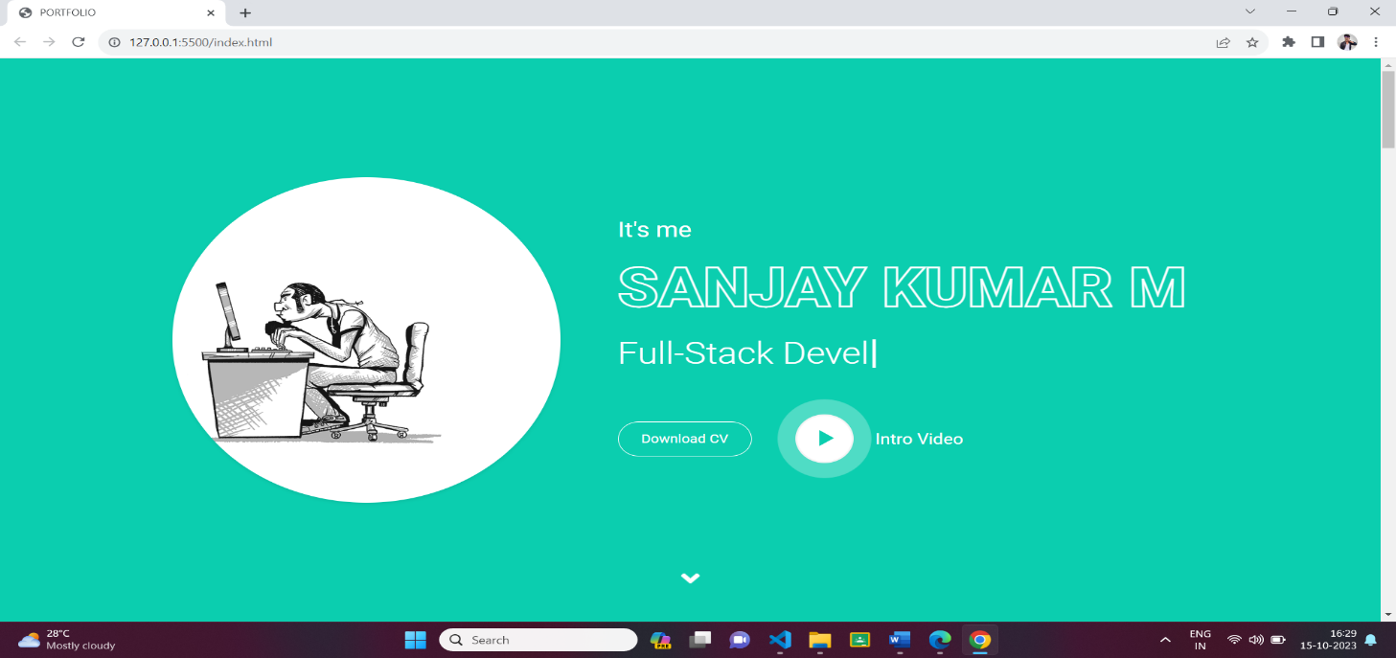

**Description:**

The above figures 3.1.1 are the screenshot of Homepage in a desktop view. And this is a home screen of the portfolio which shows the landing page with my resume and self-introduction video. which shown as figures 3.1.1.

**Source Code**: HTML:

<!-- Header Start -->

    <div class="container-fluid bg-primary d-flex align-items-center mb-5 py-5" id="home" style="min-height: 100vh;">

    <div class="container">

    <div class="row align-items-center">

    <div class="col-lg-5 px-5 pl-lg-0 pb-5 pb-lg-0">

    <img class="img-fluid w-100 rounded-circle shadow-sm" src="./gif/home.gif" alt="">

    </div><div class="col-lg-7 text-center text-lg-left">

    <h3 class="text-white font-weight-normal mb-3">It's me</h3>

    <h1 class="display-3 text-uppercase text-primary mb-2" style="-webkit-text-stroke: 2px #ffffff;">sanjay kumar m</h1>

     <h1 class="typed-text-output d-inline font-weight-lighter text-white"></h1>

     <div class="typed-text d-none"> Web Developer, Full-Stack Developer</div>

     <div class="d-flex align-items-center justify-content-center justify-content-lg-start pt-5">

     <a href="./resume/index.html" class="btn btn-outline-light mr-5">Download CV</a>

     <button type="button" class="btn-play" data-toggle="modal"

             data-src="https://www.youtube.com/embed/mct0hLWs00k" data-target="#videoModal">

     <span></span>

     </button>

     <h5 class="font-weight-normal text-white m-0 ml-4 d-none d-sm-block">Intro Video</h5>

     </div>

     </div>

     </div>

     </div>

    </div>

<!-- Header End -->

CSS:

#header .container,#header .container-fluid {

  width: 100%;

  padding-right: 15px;

  padding-left: 15px;

  margin-right: auto;

  margin-left: auto;

}

.row {

  display: flex;

  flex-wrap: wrap;

  margin-right: -15px;

  margin-left: -15px;

}

#header .col-lg-5,#header .col-px-5,#header .col-pb-5 {

    position: relative;

    width: 100%;

    padding-right: 15px;

    padding-left: 15px;

}

(Mobile view sample for one background image)

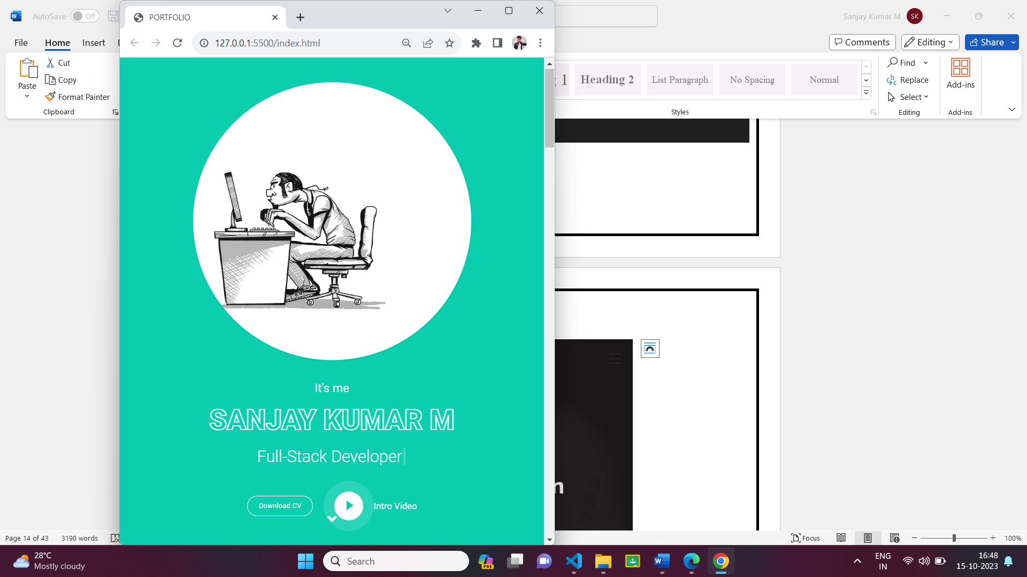

## Description:

The above figures 3.1.2 are the screenshot of Homepage in a Mobile view. And this is a home screen of the portfolio which shows the landing page with my resume and self-introduction video. which shown as figure 3.1.2

* 1. **Project Page**

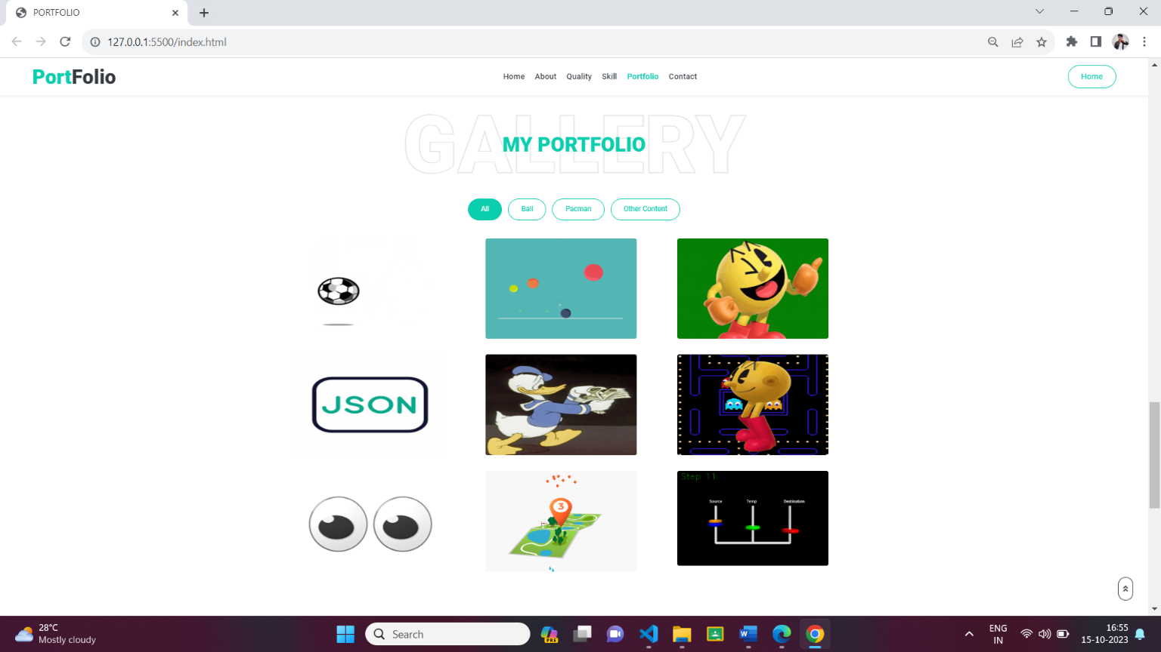

**Source Code:**

HTML:

 <!-- Portfolio Start -->

    <div class="container-fluid pt-5 pb-3" id="portfolio">

        <div class="container">

            <div class="position-relative d-flex align-items-center justify-content-center">

                <h1 class="display-1 text-uppercase text-white" style="-webkit-text-stroke: 1px #dee2e6;">Gallery</h1>

                <h1 class="position-absolute text-uppercase text-primary">My Portfolio</h1>

            </div>

            <div class="row">

                <div class="col-12 text-center mb-2">

                    <ul class="list-inline mb-4" id="portfolio-flters">

                        <li class="btn btn-sm btn-outline-primary m-1 active"  data-filter="*">All</li>

                        <li class="btn btn-sm btn-outline-primary m-1" data-filter=".first">Ball</li>

                        <li class="btn btn-sm btn-outline-primary m-1" data-filter=".second">Pacman</li>

                        <li class="btn btn-sm btn-outline-primary m-1" data-filter=".third">Other Content</li>

                    </ul>

                </div>

            </div>

            <div class="row portfolio-container">

                <div class="col-lg-4 col-md-6 mb-4 portfolio-item first">

                    <div class="position-relative overflow-hidden mb-2">

                        <img class="img-fluids rounded w-100" src="./gif/portfolio-1.gif" alt="">

                        <div class="portfolio-btn bg-primary d-flex align-items-center justify-content-center">

                            <a href="./result/portfolio-1.gif" data-lightbox="portfolio">

                                <i class="fa fa-plus text-white" style="font-size: 60px;"></i>

                            </a>

                            <a href="https://github.com/Sanjay-Kumar-SK-MCA-23/Simulation_ball_movement.git">

                                <button class="btnforgit" type="submit">github</button>

                            </a>

                        </div>

                    </div>

                </div>

                <div class="col-lg-4 col-md-6 mb-4 portfolio-item first">

                    <div class="position-relative overflow-hidden mb-2">

                        <img class="img-fluids rounded w-100" src="./gif/portfolio-2.gif" alt="">

                        <div class="portfolio-btn bg-primary d-flex align-items-center justify-content-center">

                            <a href="./result/portfolio-2.gif" data-lightbox="portfolio">

                                <i class="fa fa-plus text-white" style="font-size: 60px;"></i>

                            </a>

                            <a href="https://github.com/Sanjay-Kumar-SK-MCA-23/Graphic_animation_of_the_random_walk.git">

                                <button class="btnforgit" type="submit">github</button>

                            </a>

                        </div>

                    </div>

                </div>

                <div class="col-lg-4 col-md-6 mb-4 portfolio-item second">

                    <div class="position-relative overflow-hidden mb-2">

                        <img class="img-fluids rounded w-100" src="./gif/portfolio-3.gif" alt="">

                        <div class="portfolio-btn bg-primary d-flex align-items-center justify-content-center">

                            <a href="./result/portfolio-3.gif" data-lightbox="portfolio">

                                <i class="fa fa-plus text-white" style="font-size: 60px;"></i>

                            </a>

                            <a href="https://github.com/Sanjay-Kumar-SK-MCA-23/pacman_movement.git">

                                <button class="btnforgit" type="submit">github</button>

                            </a>

                        </div>

                    </div>

                </div>

                <div class="col-lg-4 col-md-6 mb-4 portfolio-item third">

                    <div class="position-relative overflow-hidden mb-2">

                        <img class="img-fluids rounded w-100" src="./gif/portfolio-4.gif" alt="">

                        <div class="portfolio-btn bg-primary d-flex align-items-center justify-content-center">

                            <a href="./result/portfolio-4.gif" data-lightbox="portfolio">

                                <i class="fa fa-plus text-white" style="font-size: 60px;"></i>

                            </a>

                            <a href="https://github.com/Sanjay-Kumar-SK-MCA-23/boston.git">

                                <button class="btnforgit" type="submit">github</button>

                            </a>

                        </div>

                    </div>

                </div>

                <div class="col-lg-4 col-md-6 mb-4 portfolio-item third">

                    <div class="position-relative overflow-hidden mb-2">

                        <img class="img-fluids rounded w-100" src="./gif/portfolio-5.gif" alt="">

                        <div class="portfolio-btn bg-primary d-flex align-items-center justify-content-center">

                            <a href="./result/portfolio-5.gif" data-lightbox="portfolio">

                                <i class="fa fa-plus text-white" style="font-size: 60px;"></i>

                            </a>

                            <a href="https://github.com/Sanjay-Kumar-SK-MCA-23/words_count.git">

                                <button class="btnforgit" type="submit">github</button>

                            </a>

                        </div>

                    </div>

                </div>

                <div class="col-lg-4 col-md-6 mb-4 portfolio-item second">

                    <div class="position-relative overflow-hidden mb-2">

                        <img class="img-fluids rounded w-100" src="./gif/portfolio-6.gif" alt="">

                        <div class="portfolio-btn bg-primary d-flex align-items-center justify-content-center">

                            <a href="./result/portfolio-6.gif" data-lightbox="portfolio">

                                <i class="fa fa-plus text-white" style="font-size: 60px;"></i>

                            </a>

                            <a href="https://github.com/Sanjay-Kumar-SK-MCA-23/random_pacman.git">

                                <button class="btnforgit" type="submit">github</button>

                            </a>

                        </div>

                    </div>

                </div>

                <div class="col-lg-4 col-md-6 mb-4 portfolio-item first">

                    <div class="position-relative overflow-hidden mb-2">

                    <img class="img-fluids rounded w-100" src="./gif/portfolio-7.gif" alt="">

                        <div class="portfolio-btn bg-primary d-flex align-items-center justify-content-center">

                            <a href="./result/portfolio-7.gif" data-lightbox="portfolio">

                                <i class="fa fa-plus text-white" style="font-size: 60px;"></i>

                            </a>

                            <a href="https://github.com/Sanjay-Kumar-SK-MCA-23/eye_ball.git">

                                <button class="btnforgit" type="submit">github</button>

                            </a>

                        </div>

                    </div>

                </div>

                <div class="col-lg-4 col-md-6 mb-4 portfolio-item third">

                    <div class="position-relative overflow-hidden mb-2">

                        <img class="img-fluids rounded w-100" src="./gif/portfolio-8.gif" alt="">

                        <div class="portfolio-btn bg-primary d-flex align-items-center justify-content-center">

                            <a href="./result/portfolio-8.gif" data-lightbox="portfolio">

                                <i class="fa fa-plus text-white" style="font-size: 60px;"></i>

                            </a>

                            <a href="https://github.com/Sanjay-Kumar-SK-MCA-23/map_with_start_and_destination.git">

                                <button class="btnforgit" type="submit">github</button>

                            </a>

                        </div>

                    </div>

                </div>

                <div class="col-lg-4 col-md-6 mb-4 portfolio-item third">

                    <div class="position-relative overflow-hidden mb-2">

                        <img class="img-fluids rounded w-100" src="./gif/portfolio-9.gif" alt="">

                        <div class="portfolio-btn bg-primary d-flex align-items-center justify-content-center">

                            <a href="./result/portfolio-9.gif" data-lightbox="portfolio">

                                <i class="fa fa-plus text-white" style="font-size: 60px;"></i>

                            </a>

                            <a href="https://github.com/Sanjay-Kumar-SK-MCA-23/towers_of_hanoi.git">

                                <button class="btnforgit" type="submit">github</button>

                            </a>

                        </div>

                    </div>

                </div>

            </div>

        </div>

    </div>

    <!-- Portfolio End -->

CSS:

.portfolio-item .portfolio-btn {

  position: absolute;

  width: 0;

  height: 0;

  top: 50%;

  left: 50%;

  border-radius: 4px;

  opacity: 0;

  transition: .5s;

}

.portfolio-item:hover .portfolio-btn {

  opacity: 1;

  width: calc(100% - 60px);

  height: calc(100% - 60px);

  top: 30px;

  left: 30px;

}

* 1. 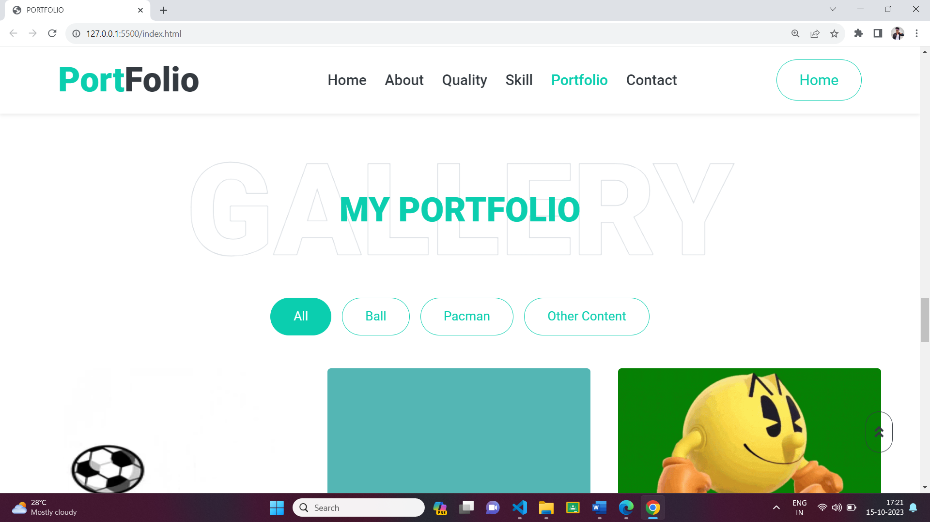**Navigation Bar**

## Description:

The above figure are the samples of navigation bar in both desktop View. This was a user-friendly method only, so the user can easily use the features.

**Source Code:**

HTML:

    <!-- Navbar Start -->

    <nav class="navbar fixed-top shadow-sm navbar-expand-lg bg-light navbar-light py-3 py-lg-0 px-lg-5">

        <a href="index.html" class="navbar-brand ml-lg-3">

            <h1 class="m-0 display-5"><span class="text-primary">Port</span>Folio</h1>

        </a>

        <button type="button" class="navbar-toggler" data-toggle="collapse" data-target="#navbarCollapse">

            <span class="navbar-toggler-icon"></span>

        </button>

        <div class="collapse navbar-collapse px-lg-3" id="navbarCollapse">

            <div class="navbar-nav m-auto py-0">

                <a href="#home" class="nav-item nav-link active">Home</a>

                <a href="#about" class="nav-item nav-link">About</a>

                <a href="#qualification" class="nav-item nav-link">Quality</a>

                <a href="#skill" class="nav-item nav-link">Skill</a>

                <a href="#portfolio" class="nav-item nav-link">Portfolio</a>

                <a href="#contact" class="nav-item nav-link">Contact</a>

            </div>

            <a href="#home" class="btn btn-outline-primary d-none d-lg-block">Home</a>

        </div>

    </nav><!-- Navbar End -->

CSS:

#hero .social-links {

  margin-top: 30px;

}

.nav {

  display: flex;

  flex-wrap: wrap;

  padding-left: 0;

  margin-bottom: 0;

  list-style: none;

}

.nav-link {

  display: block;

  padding: 0.5rem 1rem;

}

.nav-link:hover, .nav-link:focus {

  text-decoration: none;

}

.nav-link.disabled {

  color: #6c757d;

  pointer-events: none;

  cursor: default;

}

.nav-tabs {

  border-bottom: 1px solid #dee2e6;

}

.nav-tabs .nav-item {

  margin-bottom: -1px;

}

.nav-tabs .nav-link {

  border: 1px solid transparent;

  border-top-left-radius: 0.25rem;

  border-top-right-radius: 0.25rem;

}

.nav-tabs .nav-link:hover, .nav-tabs .nav-link:focus {

  border-color: #e9ecef #e9ecef #dee2e6;

}

.nav-tabs .nav-link.disabled {

  color: #6c757d;

  background-color: transparent;

  border-color: transparent;

}

.nav-tabs .nav-link.active,

.nav-tabs .nav-item.show .nav-link {

  color: #495057;

  background-color: #ffffff;

  border-color: #dee2e6 #dee2e6 #ffffff;

}

.nav-tabs .dropdown-menu {

  margin-top: -1px;

  border-top-left-radius: 0;

  border-top-right-radius: 0;

}

.nav-pills .nav-link {

  border-radius: 0.25rem;

}

.nav-pills .nav-link.active,

.nav-pills .show > .nav-link {

  color: #fff;

  background-color: #0BCEAF;

}

.nav-fill > .nav-link,

.nav-fill .nav-item {

  flex: 1 1 auto;

  text-align: center;

}

.nav-justified > .nav-link,

.nav-justified .nav-item {

  flex-basis: 0;

  flex-grow: 1;

  text-align: center;

}

.tab-content > .tab-pane {

  display: none;

}

.tab-content > .active {

  display: block;

}

.navbar {

  position: relative;

  display: flex;

  flex-wrap: wrap;

  align-items: center;

  justify-content: space-between;

  padding: 0.5rem 1rem;

}

.navbar .container,

.navbar .container-fluid, .navbar .container-sm, .navbar .container-md, .navbar .container-lg, .navbar .container-xl {

  display: flex;

  flex-wrap: wrap;

  align-items: center;

  justify-content: space-between;

}

.navbar-brand {

  display: inline-block;

  padding-top: 0.3125rem;

  padding-bottom: 0.3125rem;

  margin-right: 1rem;

  font-size: 1.25rem;

  line-height: inherit;

  white-space: nowrap;

}

.navbar-brand:hover, .navbar-brand:focus {

  text-decoration: none;

}

.navbar-nav {

  display: flex;

  flex-direction: column;

  padding-left: 0;

  margin-bottom: 0;

  list-style: none;

}

.navbar-nav .nav-link {

  padding-right: 0;

  padding-left: 0;

}

.navbar-nav .dropdown-menu {

  position: static;

  float: none;

}

.navbar-text {

  display: inline-block;

  padding-top: 0.5rem;

  padding-bottom: 0.5rem;

}

.navbar-collapse {

  flex-basis: 100%;

  flex-grow: 1;

  align-items: center;

}

.navbar-toggler {

  padding: 0.25rem 0.75rem;

  font-size: 1.25rem;

  line-height: 1;

  background-color: transparent;

  border: 1px solid transparent;

  border-radius: 0.25rem;

}

.navbar-toggler:hover, .navbar-toggler:focus {

  text-decoration: none;

}

.navbar-toggler-icon {

  display: inline-block;

  width: 1.5em;

  height: 1.5em;

  vertical-align: middle;

  content: "";

  background: no-repeat center center;

  background-size: 100% 100%;

}

@media (max-width: 575.98px) {

  .navbar-expand-sm > .container,

  .navbar-expand-sm > .container-fluid, .navbar-expand-sm > .container-sm, .navbar-expand-sm > .container-md, .navbar-expand-sm > .container-lg, .navbar-expand-sm > .container-xl {

    padding-right: 0;

    padding-left: 0;

  }

}

@media (min-width: 576px) {

  .navbar-expand-sm {

    flex-flow: row nowrap;

    justify-content: flex-start;

  }

  .navbar-expand-sm .navbar-nav {

    flex-direction: row;

  }

  .navbar-expand-sm .navbar-nav .dropdown-menu {

    position: absolute;

  }

  .navbar-expand-sm .navbar-nav .nav-link {

    padding-right: 0.5rem;

    padding-left: 0.5rem;

  }

  .navbar-expand-sm > .container,

  .navbar-expand-sm > .container-fluid, .navbar-expand-sm > .container-sm, .navbar-expand-sm > .container-md, .navbar-expand-sm > .container-lg, .navbar-expand-sm > .container-xl {

    flex-wrap: nowrap;

  }

  .navbar-expand-sm .navbar-collapse {

    display: flex !important;

    flex-basis: auto;

  }

  .navbar-expand-sm .navbar-toggler {

    display: none;

  }

}

@media (max-width: 767.98px) {

  .navbar-expand-md > .container,

  .navbar-expand-md > .container-fluid, .navbar-expand-md > .container-sm, .navbar-expand-md > .container-md, .navbar-expand-md > .container-lg, .navbar-expand-md > .container-xl {

    padding-right: 0;

    padding-left: 0;

  }

}

@media (min-width: 768px) {

  .navbar-expand-md {

    flex-flow: row nowrap;

    justify-content: flex-start;

  }

  .navbar-expand-md .navbar-nav {

    flex-direction: row;

  }

  .navbar-expand-md .navbar-nav .dropdown-menu {

    position: absolute;

  }

  .navbar-expand-md .navbar-nav .nav-link {

    padding-right: 0.5rem;

    padding-left: 0.5rem;

  }

  .navbar-expand-md > .container,

  .navbar-expand-md > .container-fluid, .navbar-expand-md > .container-sm, .navbar-expand-md > .container-md, .navbar-expand-md > .container-lg, .navbar-expand-md > .container-xl {

    flex-wrap: nowrap;

  }

  .navbar-expand-md .navbar-collapse {

    display: flex !important;

    flex-basis: auto;

  }

  .navbar-expand-md .navbar-toggler {

    display: none;

  }

}

@media (max-width: 991.98px) {

  .navbar-expand-lg > .container,

  .navbar-expand-lg > .container-fluid, .navbar-expand-lg > .container-sm, .navbar-expand-lg > .container-md, .navbar-expand-lg > .container-lg, .navbar-expand-lg > .container-xl {

    padding-right: 0;

    padding-left: 0;

  }

}

@media (min-width: 992px) {

  .navbar-expand-lg {

    flex-flow: row nowrap;

    justify-content: flex-start;

  }

  .navbar-expand-lg .navbar-nav {

    flex-direction: row;

  }

  .navbar-expand-lg .navbar-nav .dropdown-menu {

    position: absolute;

  }

  .navbar-expand-lg .navbar-nav .nav-link {

    padding-right: 0.5rem;

    padding-left: 0.5rem;

  }

  .navbar-expand-lg > .container,

  .navbar-expand-lg > .container-fluid, .navbar-expand-lg > .container-sm, .navbar-expand-lg > .container-md, .navbar-expand-lg > .container-lg, .navbar-expand-lg > .container-xl {

    flex-wrap: nowrap;

  }

  .navbar-expand-lg .navbar-collapse {

    display: flex !important;

    flex-basis: auto;

  }

  .navbar-expand-lg .navbar-toggler {

    display: none;

  }

}

@media (max-width: 1199.98px) {

  .navbar-expand-xl > .container,

  .navbar-expand-xl > .container-fluid, .navbar-expand-xl > .container-sm, .navbar-expand-xl > .container-md, .navbar-expand-xl > .container-lg, .navbar-expand-xl > .container-xl {

    padding-right: 0;

    padding-left: 0;

  }

}

@media (min-width: 1200px) {

  .navbar-expand-xl {

    flex-flow: row nowrap;

    justify-content: flex-start;

  }

  .navbar-expand-xl .navbar-nav {

    flex-direction: row;

  }

  .navbar-expand-xl .navbar-nav .dropdown-menu {

    position: absolute;

  }

  .navbar-expand-xl .navbar-nav .nav-link {

    padding-right: 0.5rem;

    padding-left: 0.5rem;

  }

  .navbar-expand-xl > .container,

  .navbar-expand-xl > .container-fluid, .navbar-expand-xl > .container-sm, .navbar-expand-xl > .container-md, .navbar-expand-xl > .container-lg, .navbar-expand-xl > .container-xl {

    flex-wrap: nowrap;

  }

  .navbar-expand-xl .navbar-collapse {

    display: flex !important;

    flex-basis: auto;

  }

  .navbar-expand-xl .navbar-toggler {

    display: none;

  }

}

.navbar-expand {

  flex-flow: row nowrap;

  justify-content: flex-start;

}

.navbar-expand > .container,

.navbar-expand > .container-fluid, .navbar-expand > .container-sm, .navbar-expand > .container-md, .navbar-expand > .container-lg, .navbar-expand > .container-xl {

  padding-right: 0;

  padding-left: 0;

}

.navbar-expand .navbar-nav {

  flex-direction: row;

}

.navbar-expand .navbar-nav .dropdown-menu {

  position: absolute;

}

.navbar-expand .navbar-nav .nav-link {

  padding-right: 0.5rem;

  padding-left: 0.5rem;

}

.navbar-expand > .container,

.navbar-expand > .container-fluid, .navbar-expand > .container-sm, .navbar-expand > .container-md, .navbar-expand > .container-lg, .navbar-expand > .container-xl {

  flex-wrap: nowrap;

}

.navbar-expand .navbar-collapse {

  display: flex !important;

  flex-basis: auto;

}

.navbar-expand .navbar-toggler {

  display: none;

}

.navbar-light .navbar-brand {

  color: rgba(0, 0, 0, 0.9);

}

.navbar-light .navbar-brand:hover, .navbar-light .navbar-brand:focus {

  color: rgba(0, 0, 0, 0.9);

}

.navbar-light .navbar-nav .nav-link {

  color: rgba(0, 0, 0, 0.5);

}

.navbar-light .navbar-nav .nav-link:hover, .navbar-light .navbar-nav .nav-link:focus {

  color: rgba(0, 0, 0, 0.7);

}

.navbar-light .navbar-nav .nav-link.disabled {

  color: rgba(0, 0, 0, 0.3);

}

.navbar-light .navbar-nav .show > .nav-link,

.navbar-light .navbar-nav .active > .nav-link,

.navbar-light .navbar-nav .nav-link.show,

.navbar-light .navbar-nav .nav-link.active {

  color: rgba(0, 0, 0, 0.9);

}

.navbar-light .navbar-toggler {

  color: rgba(0, 0, 0, 0.5);

  border-color: rgba(0, 0, 0, 0.1);

}

.navbar-light .navbar-toggler-icon {

  background-image: url("data:image/svg+xml,%3csvg xmlns='http://www.w3.org/2000/svg' width='30' height='30' viewBox='0 0 30 30'%3e%3cpath stroke='rgba%280, 0, 0, 0.5%29' stroke-linecap='round' stroke-miterlimit='10' stroke-width='2' d='M4 7h22M4 15h22M4 23h22'/%3e%3c/svg%3e");

}

.navbar-light .navbar-text {

  color: rgba(0, 0, 0, 0.5);

}

.navbar-light .navbar-text a {

  color: rgba(0, 0, 0, 0.9);

}

.navbar-light .navbar-text a:hover, .navbar-light .navbar-text a:focus {

  color: rgba(0, 0, 0, 0.9);

}

.navbar-dark .navbar-brand {

  color: #fff;

}

.navbar-dark .navbar-brand:hover, .navbar-dark .navbar-brand:focus {

  color: #fff;

}

.navbar-dark .navbar-nav .nav-link {

  color: rgba(255, 255, 255, 0.5);

}

.navbar-dark .navbar-nav .nav-link:hover, .navbar-dark .navbar-nav .nav-link:focus {

  color: rgba(255, 255, 255, 0.75);

}

.navbar-dark .navbar-nav .nav-link.disabled {

  color: rgba(255, 255, 255, 0.25);

}

.navbar-dark .navbar-nav .show > .nav-link,

.navbar-dark .navbar-nav .active > .nav-link,

.navbar-dark .navbar-nav .nav-link.show,

.navbar-dark .navbar-nav .nav-link.active {

  color: #fff;

}

.navbar-dark .navbar-toggler {

  color: rgba(255, 255, 255, 0.5);

  border-color: rgba(255, 255, 255, 0.1);

}

.navbar-dark .navbar-toggler-icon {

  background-image: url("data:image/svg+xml,%3csvg xmlns='http://www.w3.org/2000/svg' width='30' height='30' viewBox='0 0 30 30'%3e%3cpath stroke='rgba%28255, 255, 255, 0.5%29' stroke-linecap='round' stroke-miterlimit='10' stroke-width='2' d='M4 7h22M4 15h22M4 23h22'/%3e%3c/svg%3e");

}

.navbar-dark .navbar-text {

  color: rgba(255, 255, 255, 0.5);

}

.navbar-dark .navbar-text a {

  color: #fff;

}

.navbar-dark .navbar-text a:hover, .navbar-dark .navbar-text a:focus {

  color: #fff;

}

Mobile View

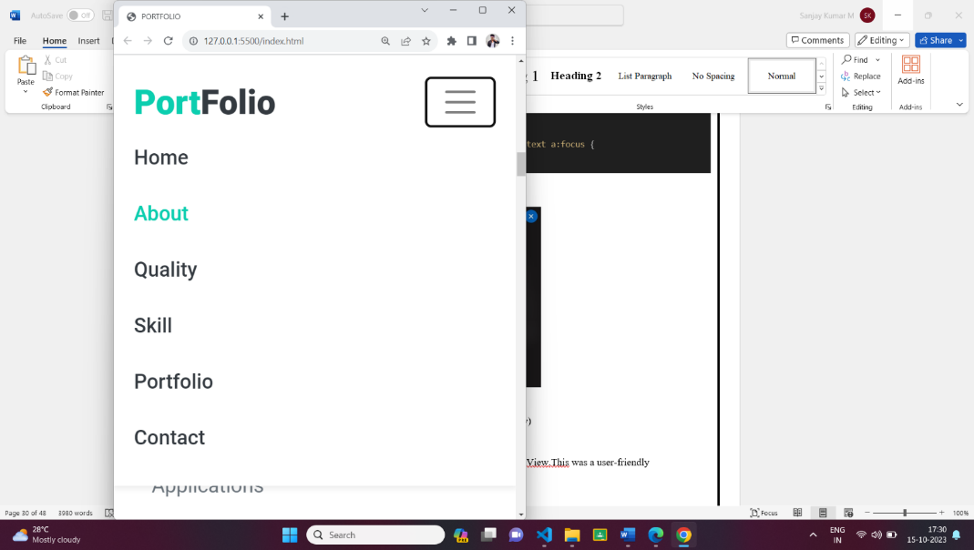

## Description:

The above figure are the samples of navigation bar in both mobile View. This was a user-friendly method only, so the user can easily use the features.

## Features:

There are many styles are added. Whenever the user move lists to the navigation bar it will change the color to goldenrod. And also the navigation bar will be stable in the same position, even we switch to any other pages.

**3.4. Skills:**

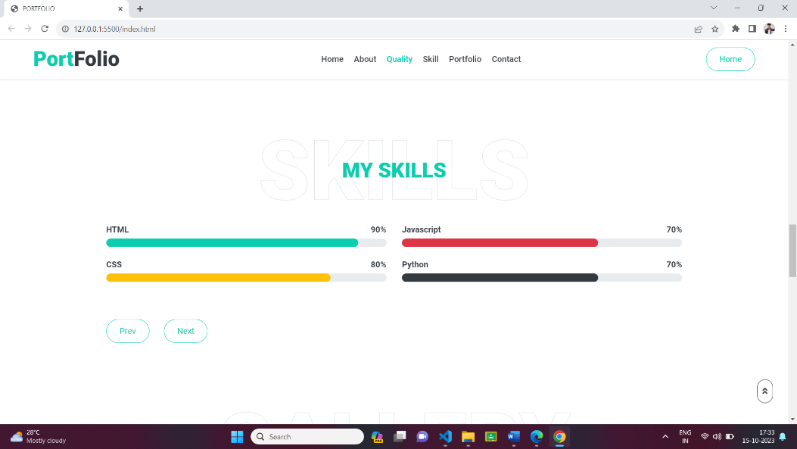

## Description:

The above figures are skill page, which contain a subdivision named PERSONAL SKILLS. Basically, it is an animation, when the user load the page it will load or fill the color in the bar from 0th position.

**Source Code:**

HTML:

 <!-- Skill Start -->

    <div class="container-fluid py-5" id="skill">

        <div class="container">

            <div class="position-relative d-flex align-items-center justify-content-center">

                <h1 class="display-1 text-uppercase text-white" style="-webkit-text-stroke: 1px #dee2e6;">Skills</h1>

                <h1 class="position-absolute text-uppercase text-primary">My Skills</h1>

            </div>

            <div class="row align-items-center">

                <div class="col-md-6">

                    <div class="skill mb-4">

                        <div class="d-flex justify-content-between">

                            <h6 class="font-weight-bold">HTML</h6>

                            <h6 class="font-weight-bold">90%</h6>

                        </div>

                        <div class="progress">

                            <div class="progress-bar bg-primary" role="progressbar" aria-valuenow="90" aria-valuemin="0" aria-valuemax="100"></div>

                        </div>

                    </div>

                    <div class="skill mb-4">

                        <div class="d-flex justify-content-between">

                            <h6 class="font-weight-bold">CSS</h6>

                            <h6 class="font-weight-bold">80%</h6>

                        </div>

                        <div class="progress">

                            <div class="progress-bar bg-warning" role="progressbar" aria-valuenow="80" aria-valuemin="0" aria-valuemax="100"></div>

                        </div>

                    </div>

                </div>

                <div class="col-md-6">

                    <div class="skill mb-4">

                        <div class="d-flex justify-content-between">

                            <h6 class="font-weight-bold">Javascript</h6>

                            <h6 class="font-weight-bold">70%</h6>

                        </div>

                        <div class="progress">

                            <div class="progress-bar bg-danger" role="progressbar" aria-valuenow="70" aria-valuemin="0" aria-valuemax="100"></div>

                        </div>

                    </div>

                    <div class="skill mb-4">

                        <div class="d-flex justify-content-between">

                            <h6 class="font-weight-bold">Python</h6>

                            <h6 class="font-weight-bold">70%</h6>

                        </div>

                        <div class="progress">

                            <div class="progress-bar bg-dark" role="progressbar" aria-valuenow="70" aria-valuemin="0" aria-valuemax="100"></div>

                        </div>

                    </div>

                </div>

            </div><br><br>

            <a href="#qualification" class="btn btn-outline-primary mr-4">Prev</a>

            <a href="#portfolio" class="btn btn-outline-primary">Next</a>

        </div>

    </div>

    <!-- Skill End -->

CSS:

.progress {

  display: flex;

  height: 1rem;

  overflow: hidden;

  line-height: 0;

  font-size: 0.75rem;

  background-color: #e9ecef;

  border-radius: 0.25rem;

}

.progress-bar {

  display: flex;

  flex-direction: column;

  justify-content: center;

  overflow: hidden;

  color: #fff;

  text-align: center;

  white-space: nowrap;

  background-color: #0BCEAF;

  transition: width 0.6s ease;

}

@media (prefers-reduced-motion: reduce) {

  .progress-bar {

    transition: none;

  }

}

.progress-bar-striped {

  background-image: linear-gradient(45deg, rgba(255, 255, 255, 0.15) 25%, transparent 25%, transparent 50%, rgba(255, 255, 255, 0.15) 50%, rgba(255, 255, 255, 0.15) 75%, transparent 75%, transparent);

  background-size: 1rem 1rem;

}

.progress-bar-animated {

  animation: progress-bar-stripes 1s linear infinite;

}

@media (prefers-reduced-motion: reduce) {

  .progress-bar-animated {

    animation: none;

  }

}

.progress {

  border-radius: 10px;

}

.progress .progress-bar {

  width: 0px;

  border-radius: 10px;

  transition: 2s;

}

.service-icon {

  width: 60px;

  height: 60px;

  display: flex;

  align-items: center;

  justify-content: center;

  border-radius: 60px;

## Chapter 4:

## 4.1 Styles

.typed-cursor {

  font-size: 45px;

  color: #ffffff;

}

.btn-play {

  position: relative;

  display: block;

  box-sizing: content-box;

  width: 16px;

  height: 26px;

  border-radius: 100%;

  border: none;

  outline: none !important;

  padding: 18px 20px 20px 28px;

}

.btn-play:before {

  content: "";

  position: absolute;

  z-index: 0;

  left: 50%;

  top: 50%;

  transform: translateX(-50%) translateY(-50%);

  display: block;

  width: 60px;

  height: 60px;

  background: #ffffff;

  border-radius: 100%;

  animation: pulse-border 1500ms ease-out infinite;

}

.btn-play:after {

  content: "";

  position: absolute;

  z-index: 1;

  left: 50%;

  top: 50%;

  transform: translateX(-50%) translateY(-50%);

  display: block;

  width: 60px;

  height: 60px;

  background: #ffffff;

  border-radius: 100%;

  transition: all 200ms;

}

.btn-play span {

  display: block;

  position: relative;

  z-index: 3;

  width: 0;

  height: 0;

  left: -1px;

  border-left: 16px solid #0BCEAF;

  border-top: 11px solid transparent;

  border-bottom: 11px solid transparent;

}

.scroll-to-bottom {

  position: fixed;

  width: 20px;

  left: calc(50% - 10px);

  bottom: 30px;

  z-index: 11;

  animation: action 1s infinite alternate;

}

.back-to-top {

  position: fixed;

  display: none;

  width: 30px;

  text-align: center;

  right: 30px;

  bottom: 30px;

  z-index: 11;

  animation: action 1s infinite alternate;

}

## 4.2. Style Links

   <link href="https://cdnjs.cloudflare.com/ajax/libs/font-awesome/6.4.2/css/all.min.css" rel="stylesheet">

  <link rel="preconnect" href="https://fonts.gstatic.com">

   <link rel="stylesheet" href="https://fonts.googleapis.com/css2?family=Roboto:wght@300;400;500;700;900&display=swap">

<link href="https://cdnjs.cloudflare.com/ajax/libs/font-awesome/5.10.0/css/all.min.css" rel="stylesheet">

  <link href="lib/owlcarousel/assets/owl.carousel.min.css" rel="stylesheet">

   <link href="lib/lightbox/css/lightbox.min.css" rel="stylesheet">

   <link href="css/style.css" rel="stylesheet">

**Chapter 5:**

**Website include the following Information**

**5.1 Project links to GitHub:**

## PROJECT-1

**Title**: **SIMULATION BALL MOVEMENT**

**Link**: <https://sanjay-kumar-sk-mca-23.github.io/Simulation_ball_movement/>

## Project Description:

This project has a simple red color ball, which will move from top to bottom and bottom to top, like bouncing from between the x and y axis. It will repeat this process whenever we load the page.

The ball is created by HTML, CSS. And making the ball to do some event by JAVASCRIPT. I Given My Project Link And Output Here..

**PROJECT-2**

**Title**: **GRAPHIC ANIMATION OF THE RANDOM WALK**

**Link**: <https://sanjay-kumar-sk-mca-23.github.io/Graphic_animation_of_the_random_walk/>

## Project Description:

This project moving Random Ball in Small Container. First I give sample of the three balls in output. You Like Give move Ball its run.Its Run x & y axis in random sides.

**PROJECT-3**

**Title**: **PACMAN MOVEMENT**

**Link**: <https://sanjay-kumar-sk-mca-23.github.io/pacman_movement/>

## Project Description:

An array arr holds the file names of Pac-Man images used for animation.The Pac-Man

image source is updated to create the mouth-open/close animation effect.

The position variable is adjusted based on direction and velocity, causing Pac-Man to move back and forth.Pac-Man's position and styling are updated dynamically within the "box" container.

## PROJECT-4

**Title:** **BOSTON CITY DATA**

**Link:** <https://sanjay-kumar-sk-mca-23.github.io/boston/>

## Project Description:

I Given Boston File in Some Employers Details. Then I create extra one boston in name of boston 1. I linked in Two JavaScript File in Html. And run the Code Given Best Salary Persons Details Showing Desktop.

## PROJECT-5

**Title**: **WORD COUNT**

**Link:** <https://sanjay-kumar-sk-mca-23.github.io/words_count/>

## Project Description:

This project was give paragraph then count the artical letters. And given the paragraph some Special characters on empty. So I given Project link and Output here.

## PROJECT-6

**Title:** **RANDOM PACMAN**

**Link:** <https://sanjay-kumar-sk-mca-23.github.io/random_pacman/>

## Project Description:

If you click the "Add PacMan" button, a new pacman should appear at a random position on the screen. If you click the "Start Game" button, the pacman or pacmen created should start moving at random velocity on the screen. The a given pacman hits the edge of the screen, it should change position to stay within the frame of the web page.

## PROJECT-7

**Title:** **EYE BALL MOVEMENT**

**Link:** <https://sanjay-kumar-sk-mca-23.github.io/eye_ball/>

## Project Description:

The overall program creates a visual representation of a face with two eyes and a mouth. The eyes follow the mouse movement, providing an interactive and dynamic effect. The colors, sizes, and positions of the elements are defined through CSS, and the interaction is handled through JavaScript. This example showcases a combination of HTML, CSS, and JavaScript to create a simple and interactive graphical element.

## PROJECT-8

**Title:** **MAP ANIMATION**

## Link: <https://sanjay-kumar-sk-mca-23.github.io/map_with_start_and_destination/>

## Project Description:

## This program showcases a simple web page with a Mapbox map. It initializes a map, places a marker at the first set of coordinates, and then animates the marker along a predefined array of coordinates (busStops). The animation is triggered by clicking a button in the map overlay. The provided Mapbox access token is essential for using Mapbox services. Overall, the program demonstrates basic map interaction and animation using Mapbox GL.

## PROJECT-9

**Title:** **HANOI TOWER**

**Link:** <https://sanjay-kumar-sk-mca-23.github.io/towers_of_hanoi/>

## Project Description:

The Tower of Hanoi is a classic puzzle where the objective is to move a stack of disks from one peg to another.

How to run the code:

Step 1: Save the HTML file with .html extension.

Step 2: Click the "Go Live" button. A new browser window will open, displaying Hanoi-Towers puzzle.

**6.1 Uses of Bootstrap:**

## Chapter 6: Bootstrap

<script src="https://code.jquery.com/jquery-3.4.1.min.js"></script>

    <script src="https://stackpath.bootstrapcdn.com/bootstrap/4.4.1/js/bootstrap.bundle.min.js"></script>

    <script src="lib/typed/typed.min.js"></script>

    <script src="lib/easing/easing.min.js"></script>

    <script src="lib/waypoints/waypoints.min.js"></script>

    <script src="lib/owlcarousel/owl.carousel.min.js"></script>

    <script src="lib/isotope/isotope.pkgd.min.js"></script>

    <script src="lib/lightbox/js/lightbox.min.js"></script>

**Description:**

I have used bootstrap in this website. Which was built in CSS file, so we can use it to reduce our time and also it carries a number of designs. So, I had linked them to the code in HTML.

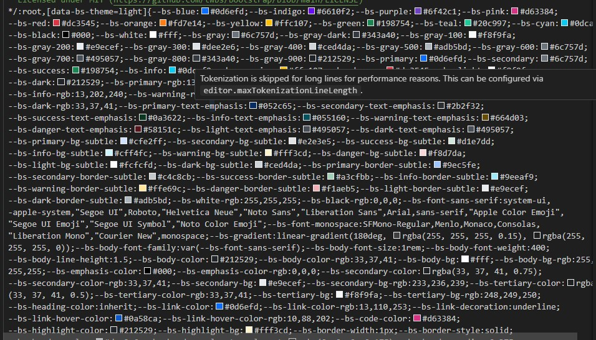

## Chapter 7: Project README

## 

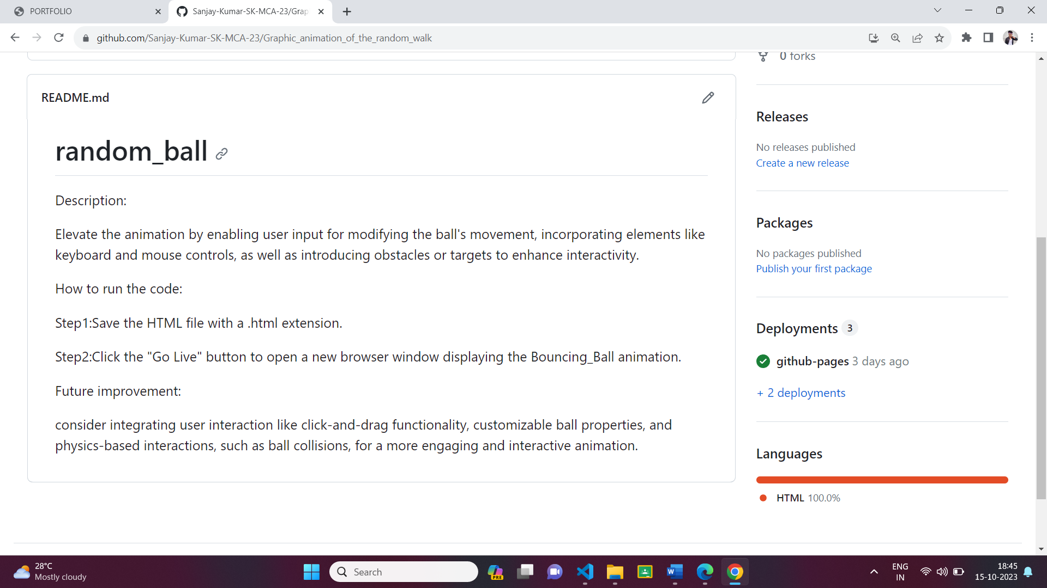

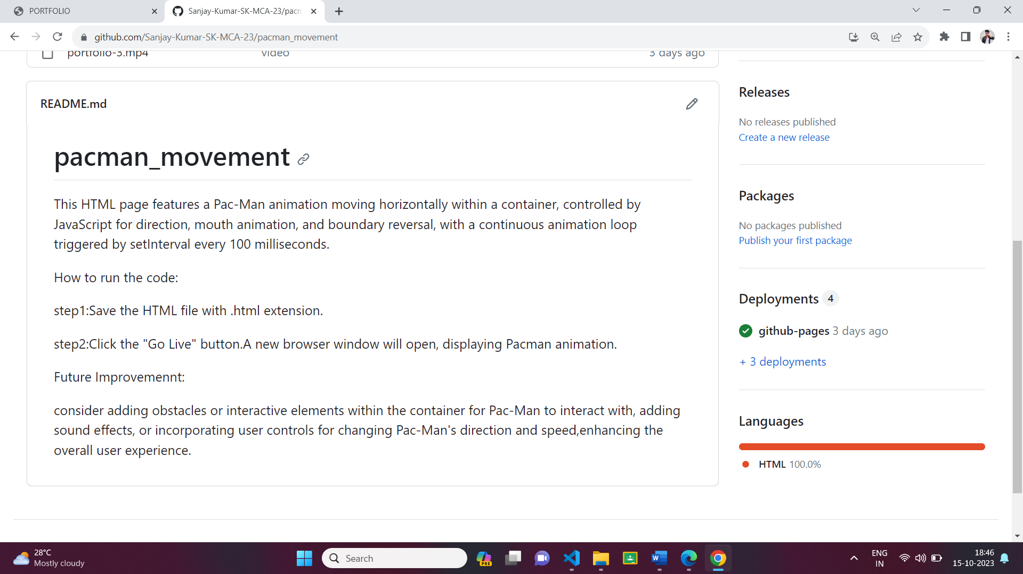

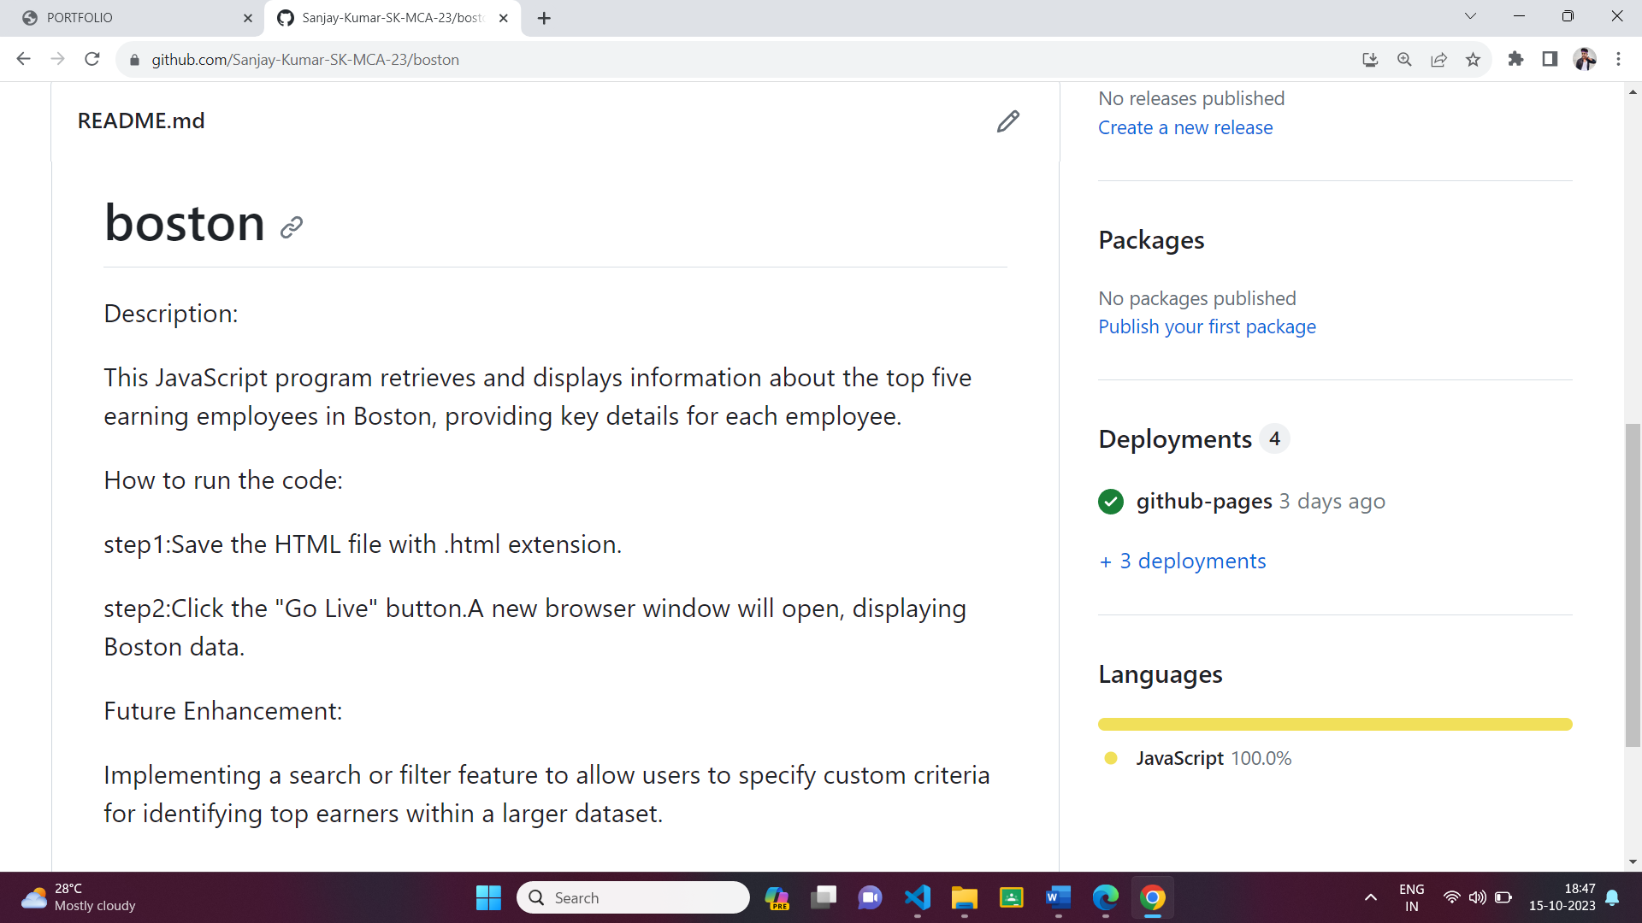

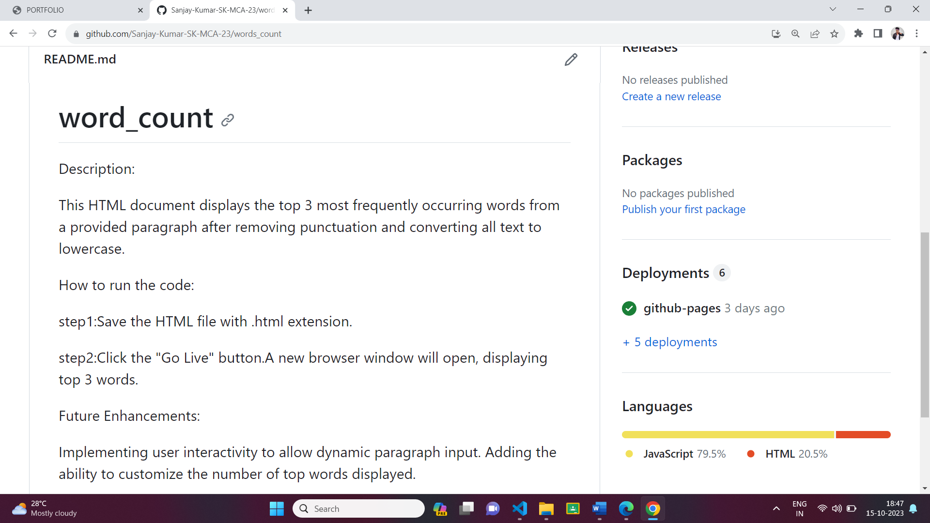

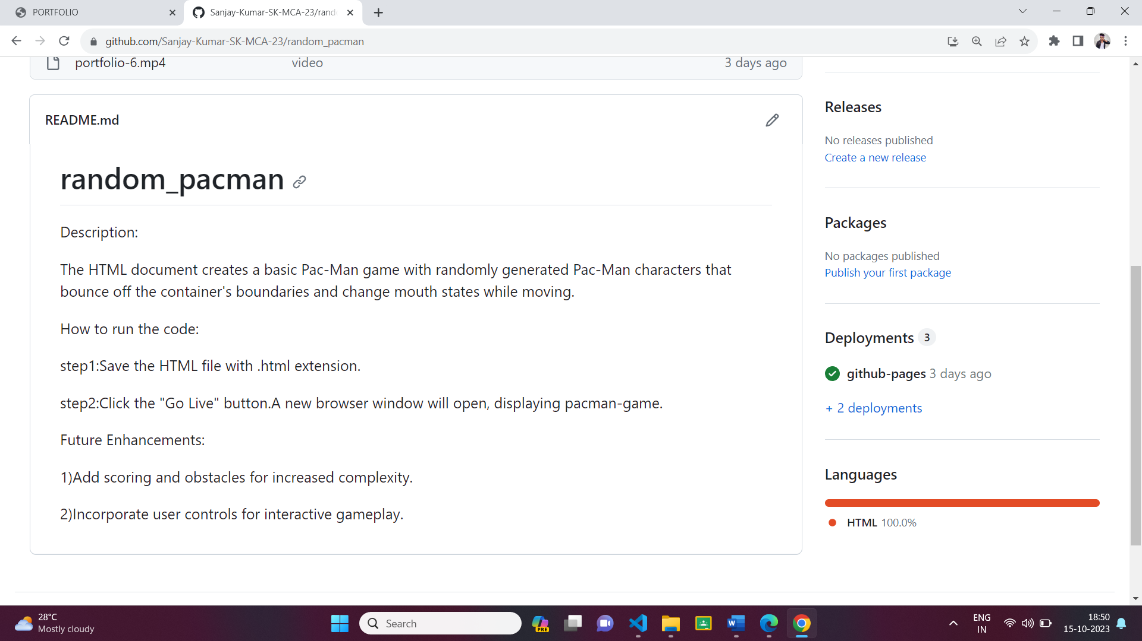

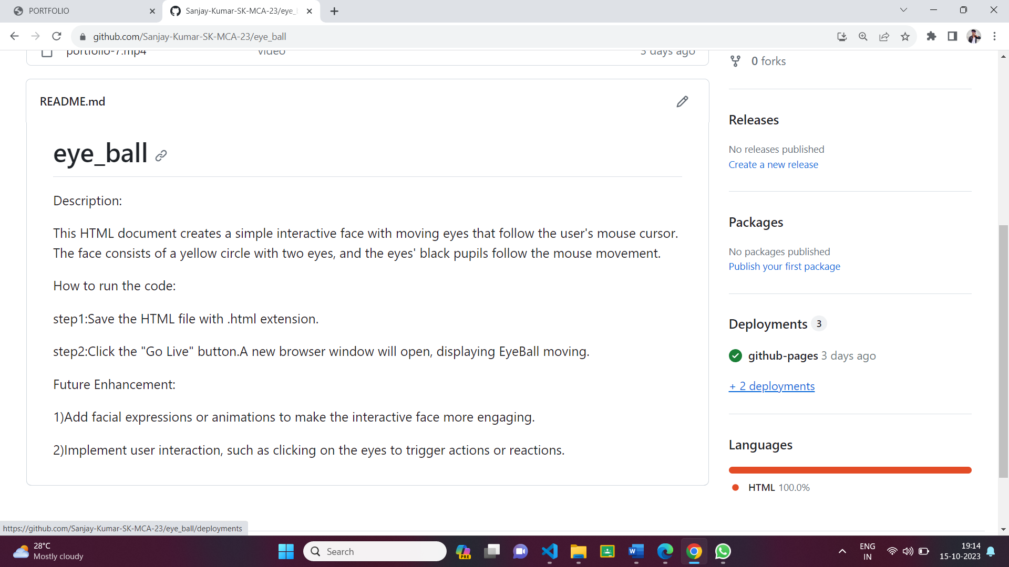

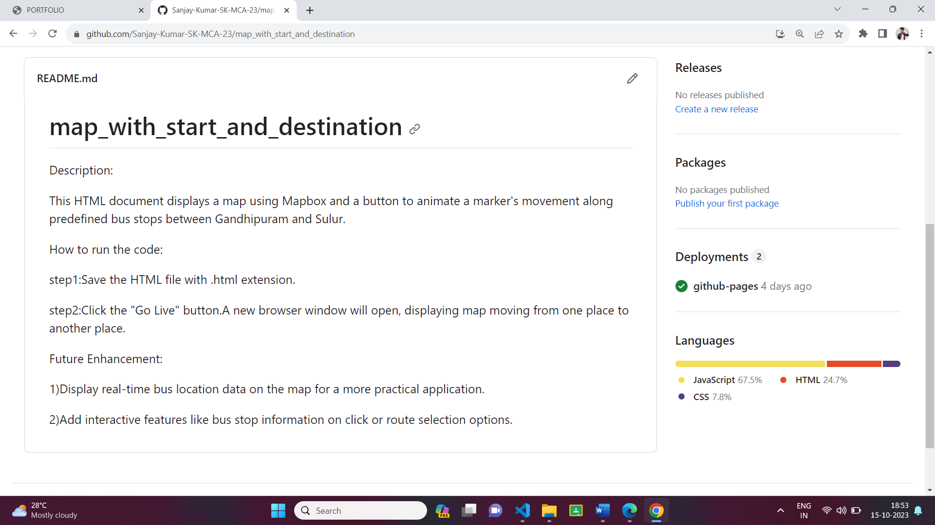

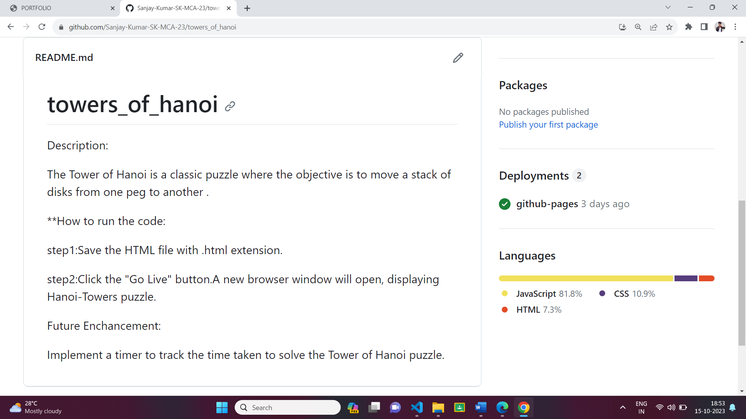

**Description:**

The above figures are the screenshot of project README files (Description, steps to run, future improvement) in a desktop view.

## 

## Chapter 8:

## File Structure

**SIMULATION BALL MOVEMENT:**

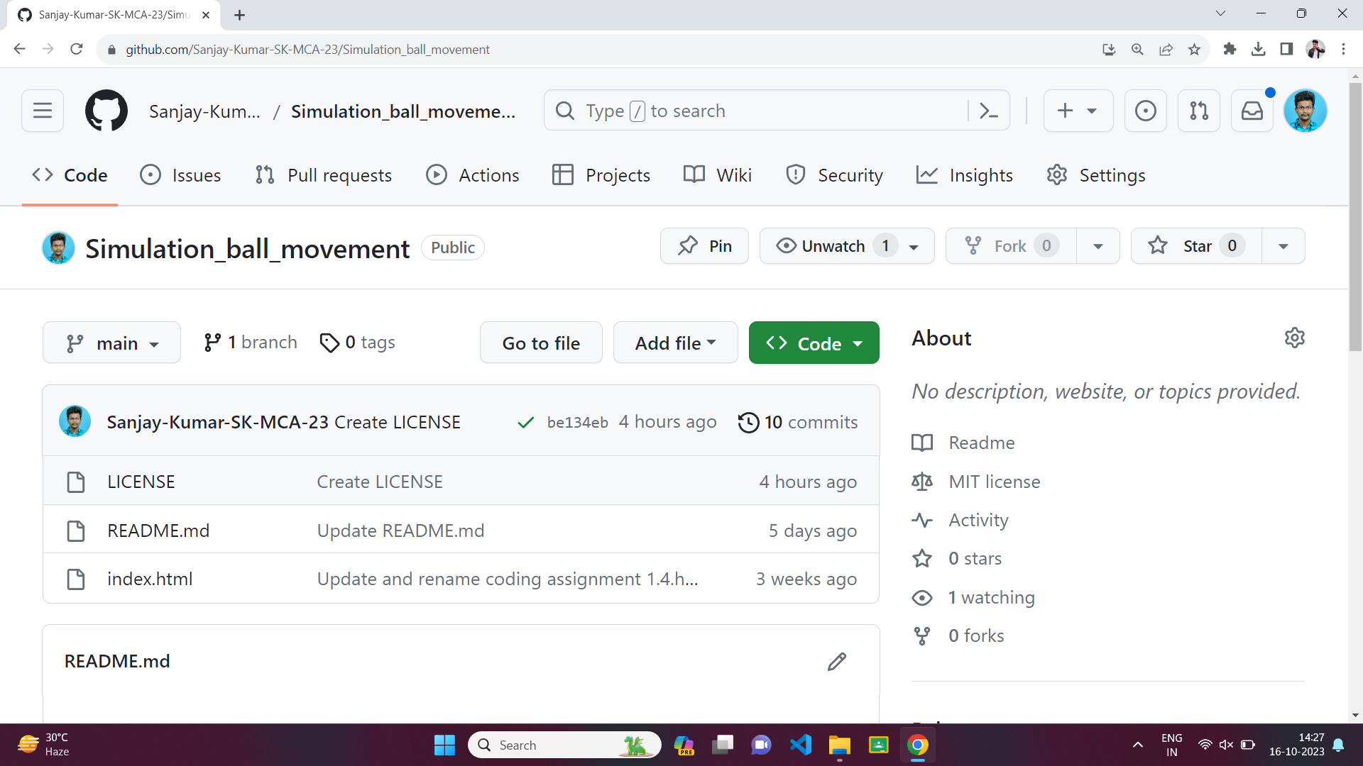

**GRAPHIC ANIMATION OF THE RANDOM WALK:**

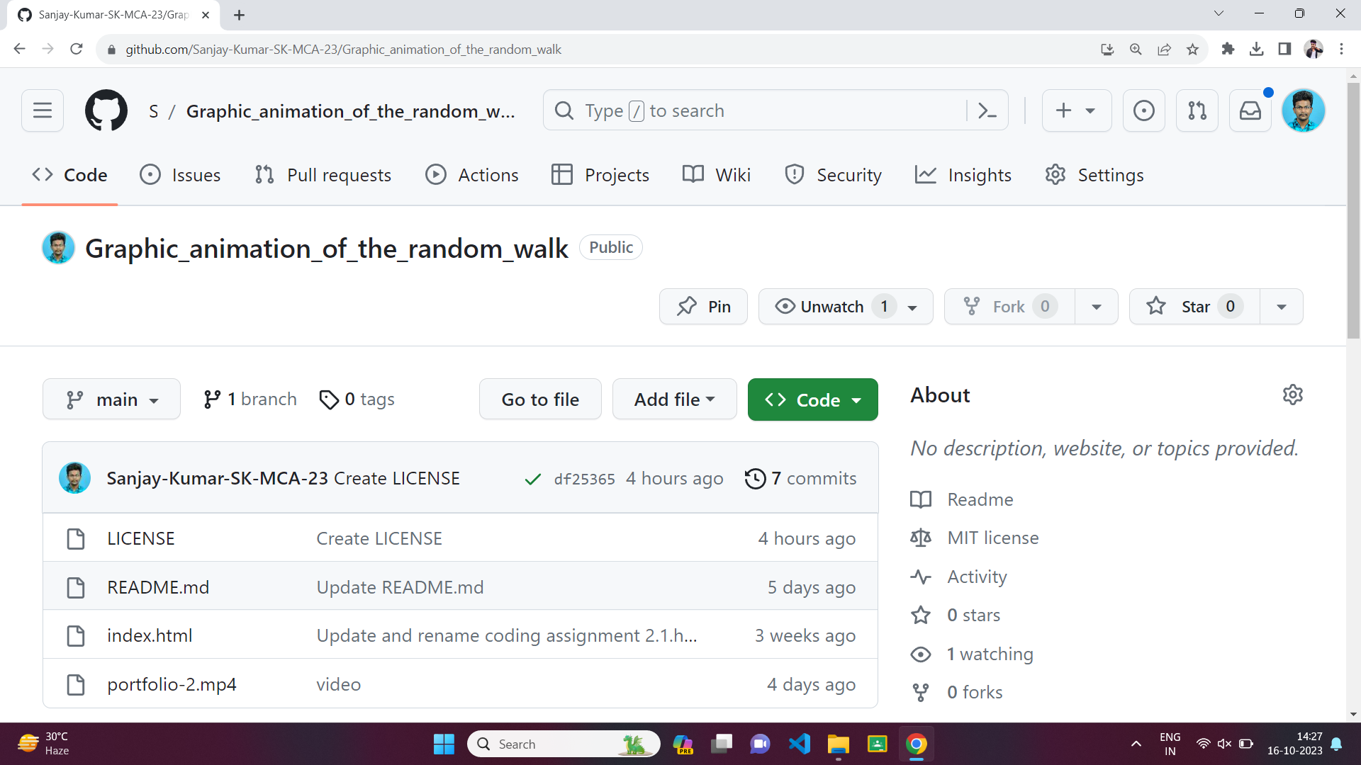

**PACMAN MOVEMENT:**

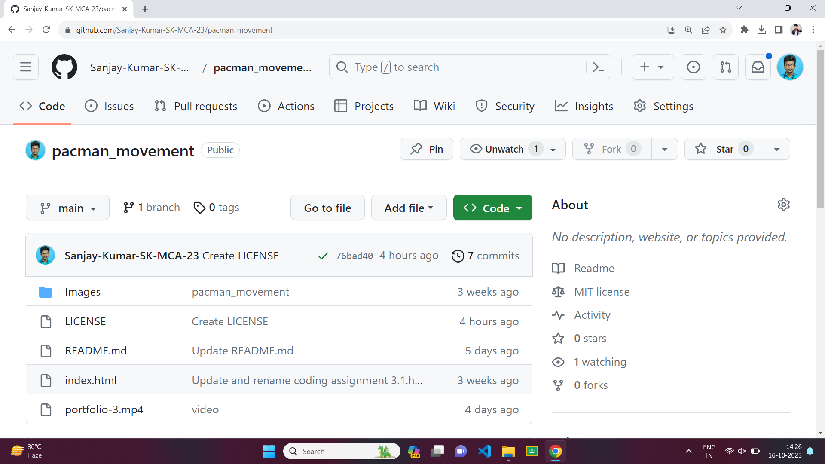

**BOSTON DATA:**

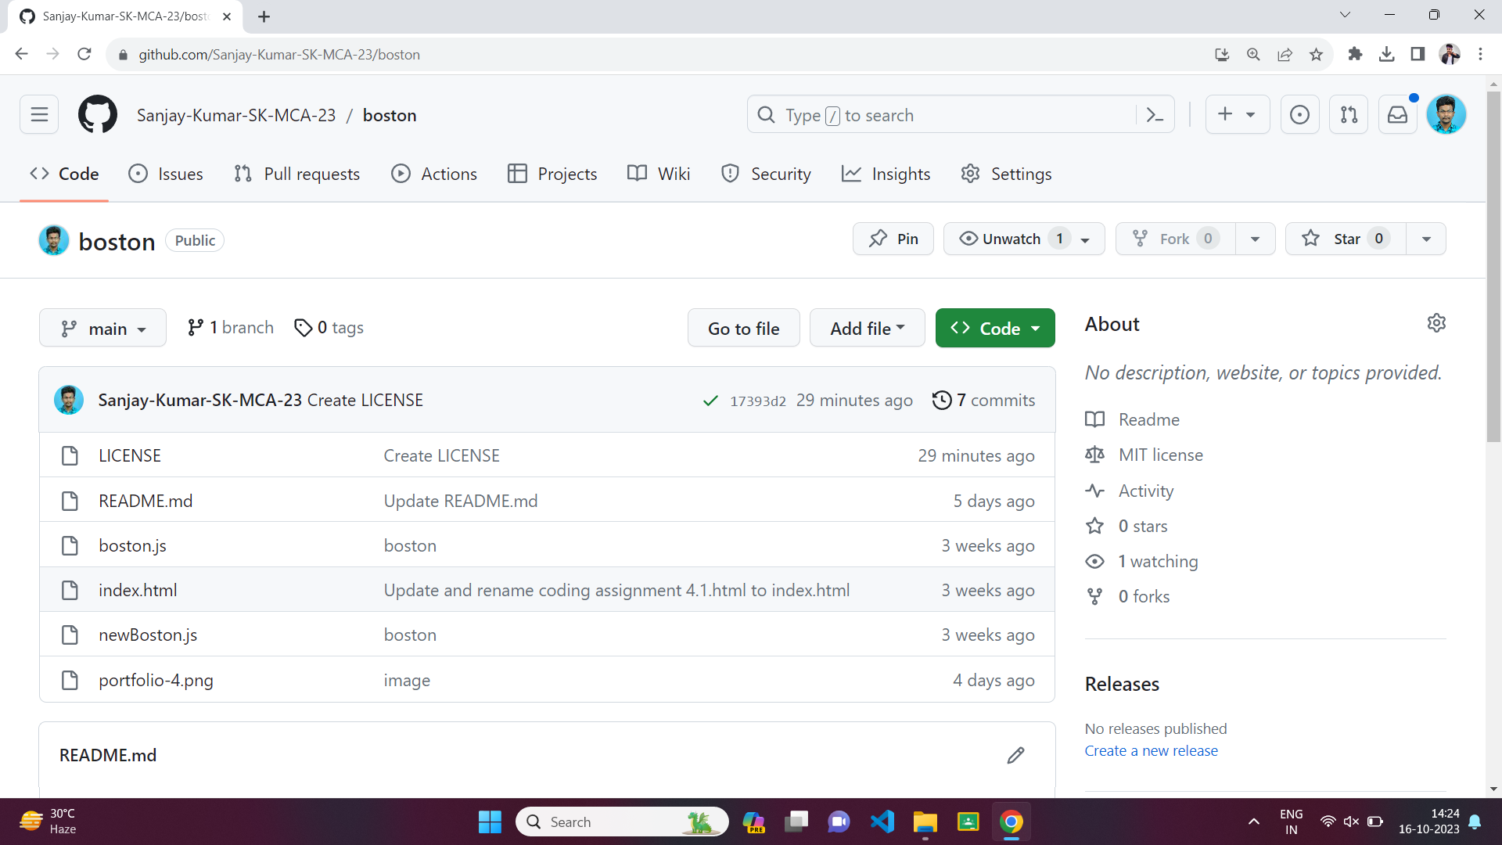

**WORD COUNT:**

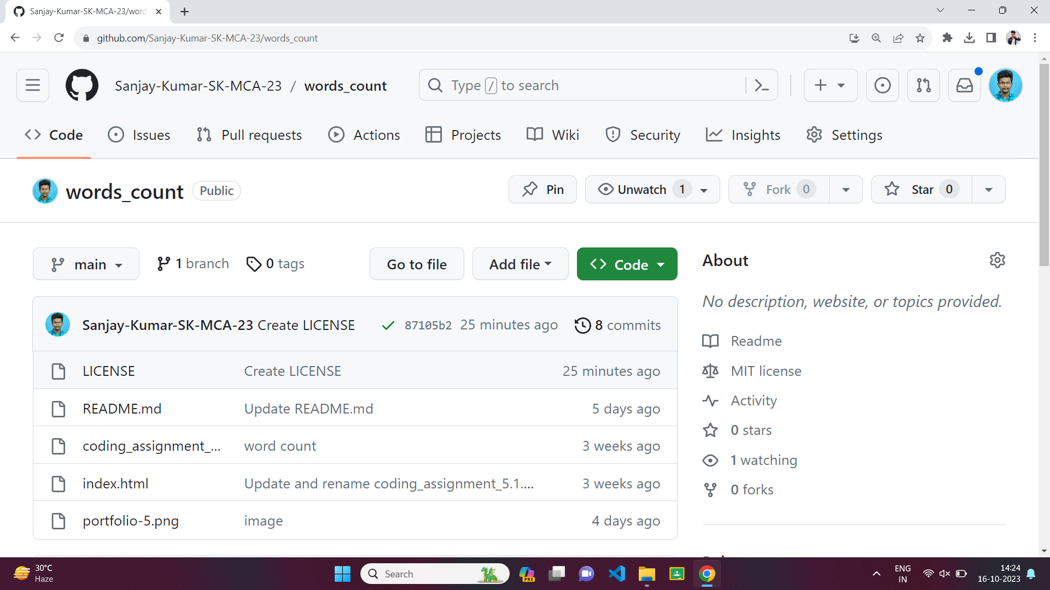

**RANDOM PACMAN:**

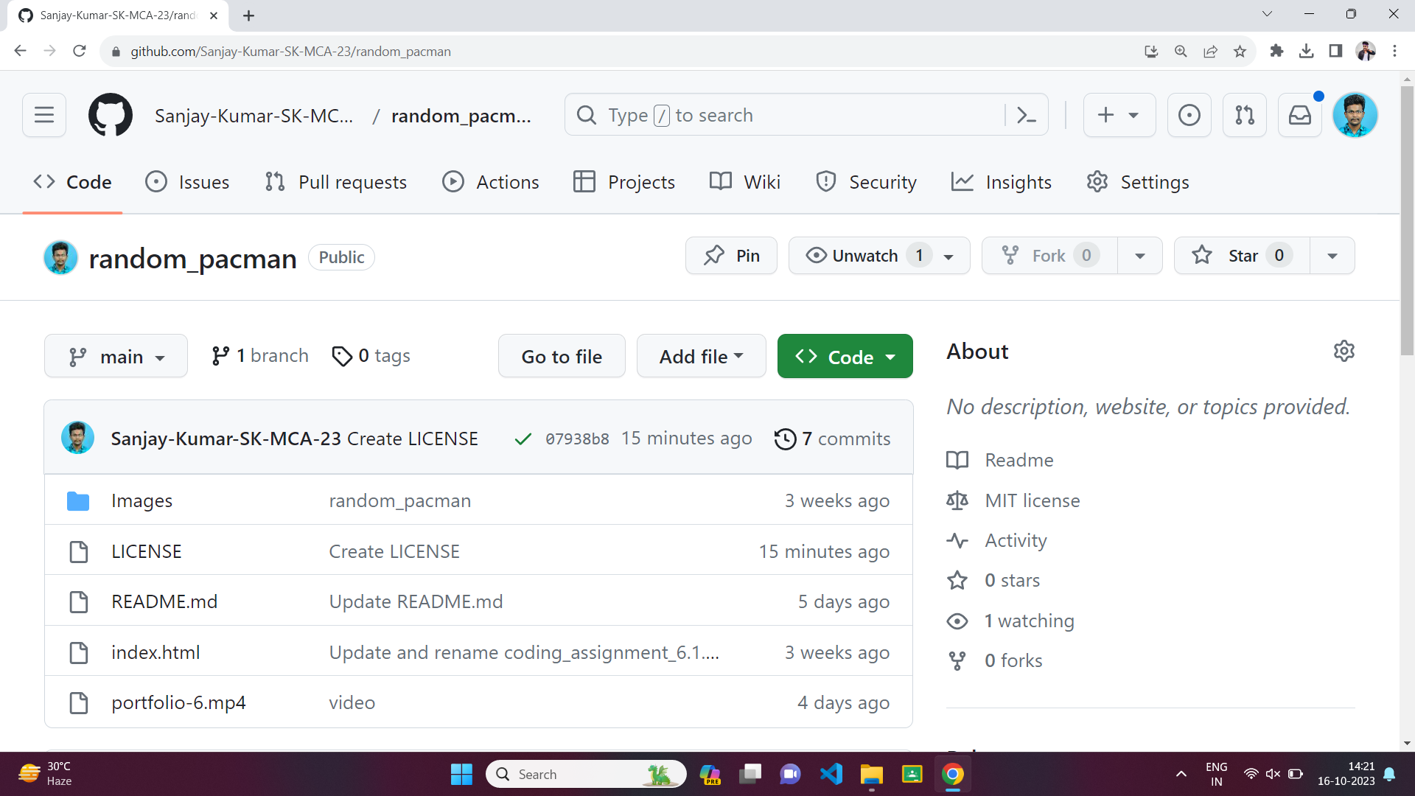

**EYE BALL:**

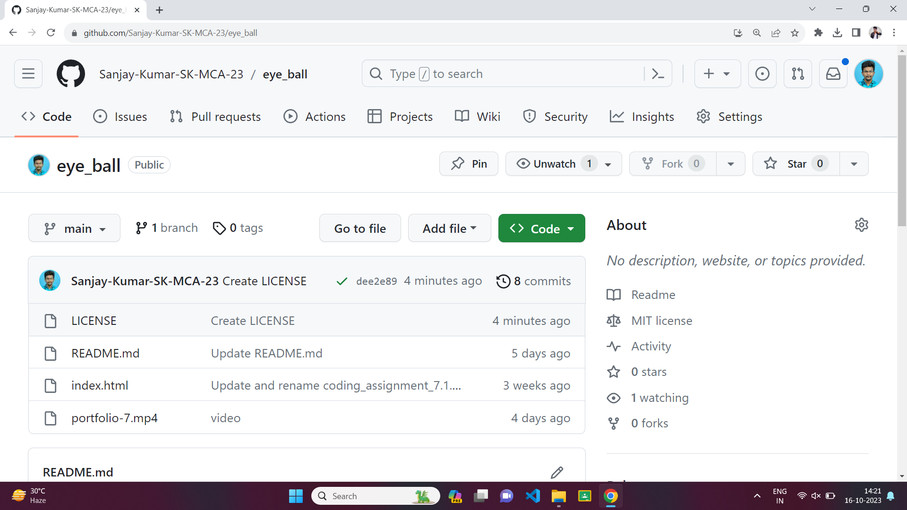

**ROUTE MAPBOX:**

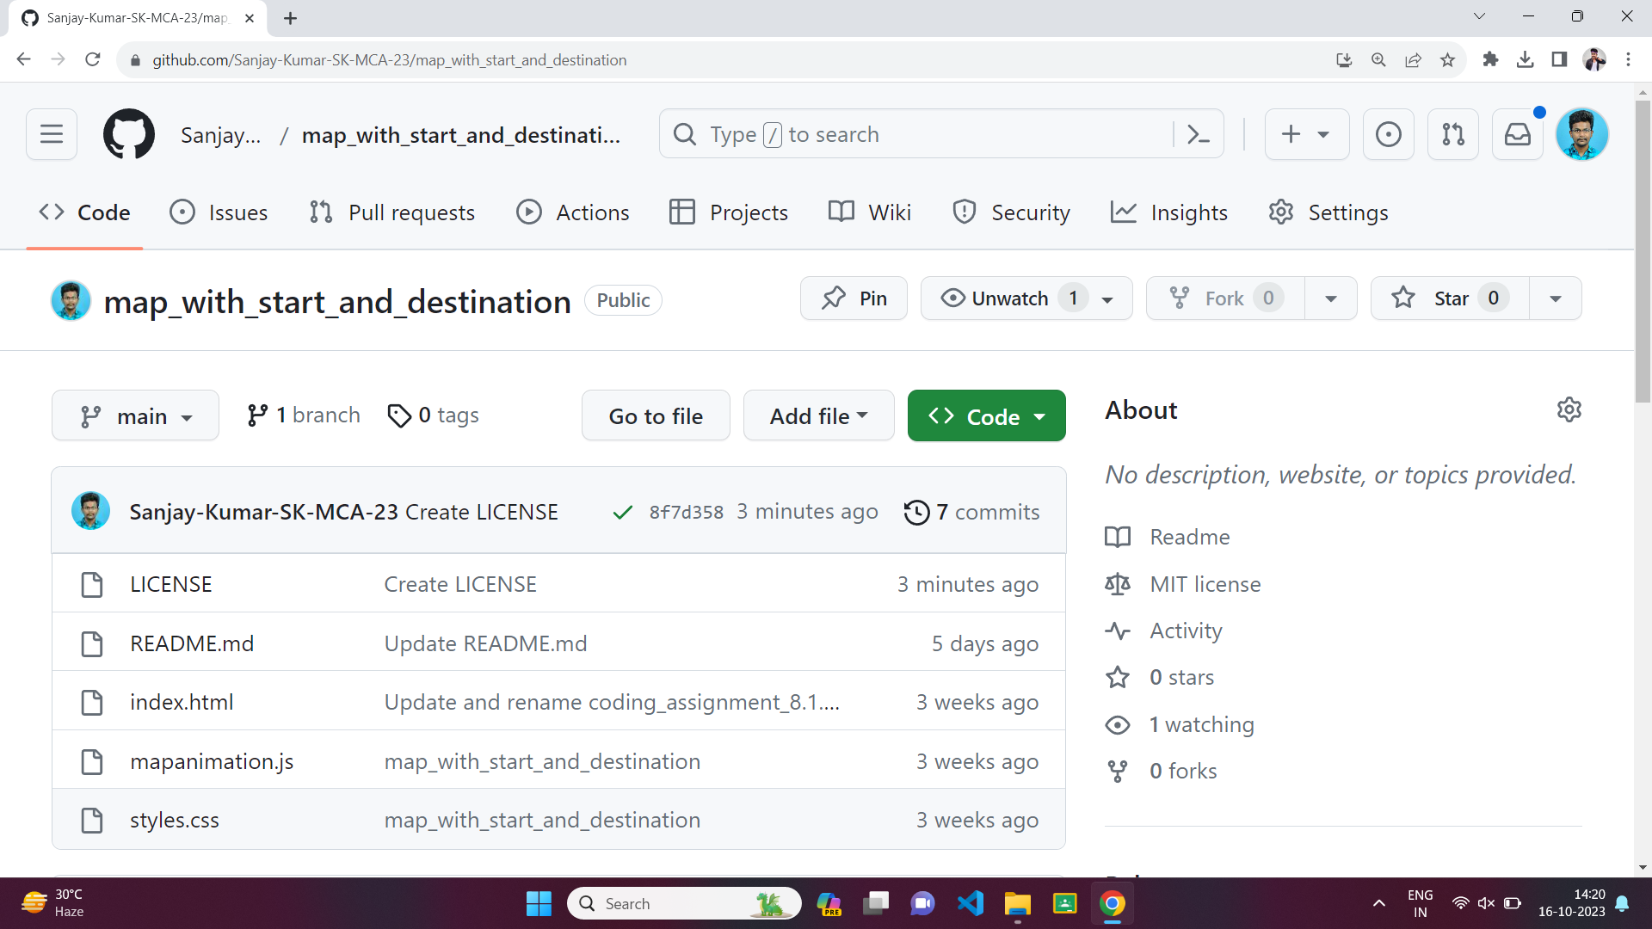

**TOWERS OF HANOI:**

